**Sheet 3**

**Question 1 true or false**

a) T F The mask shown below is appropriate for sharpening an image.

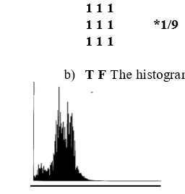

b) T F The histogram shown below corresponds to a high contrast image.

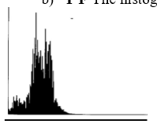

c) T F weighted average filter is a statistics order filtering technique.

d) T F Histogram equalization is an example of contrast stretching.

e) T F Median filtering can be implemented using convolution.

**Question 2**

A 4x4 image is given as follow. The image is transformed using the point transform shown.

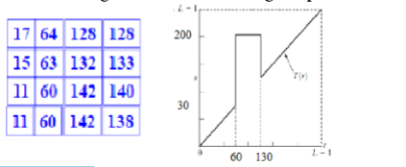

a) Find the pixel values of the output image.